The Context API in React addresses the problem of prop drilling, where passing props through multiple nested components becomes cumbersome. Instead of manually passing props down the component tree, the Context API allows components to access state that is shared globally across a specific context.

**Key points about the Context API**

**Problem**

In complex React applications, passing state through deeply nested components via props (prop drilling) is inconvenient and can clutter the code.

**Solution**

React's Context API provides a mechanism to broadcast state data to all child components within a context without explicitly passing props through each level.

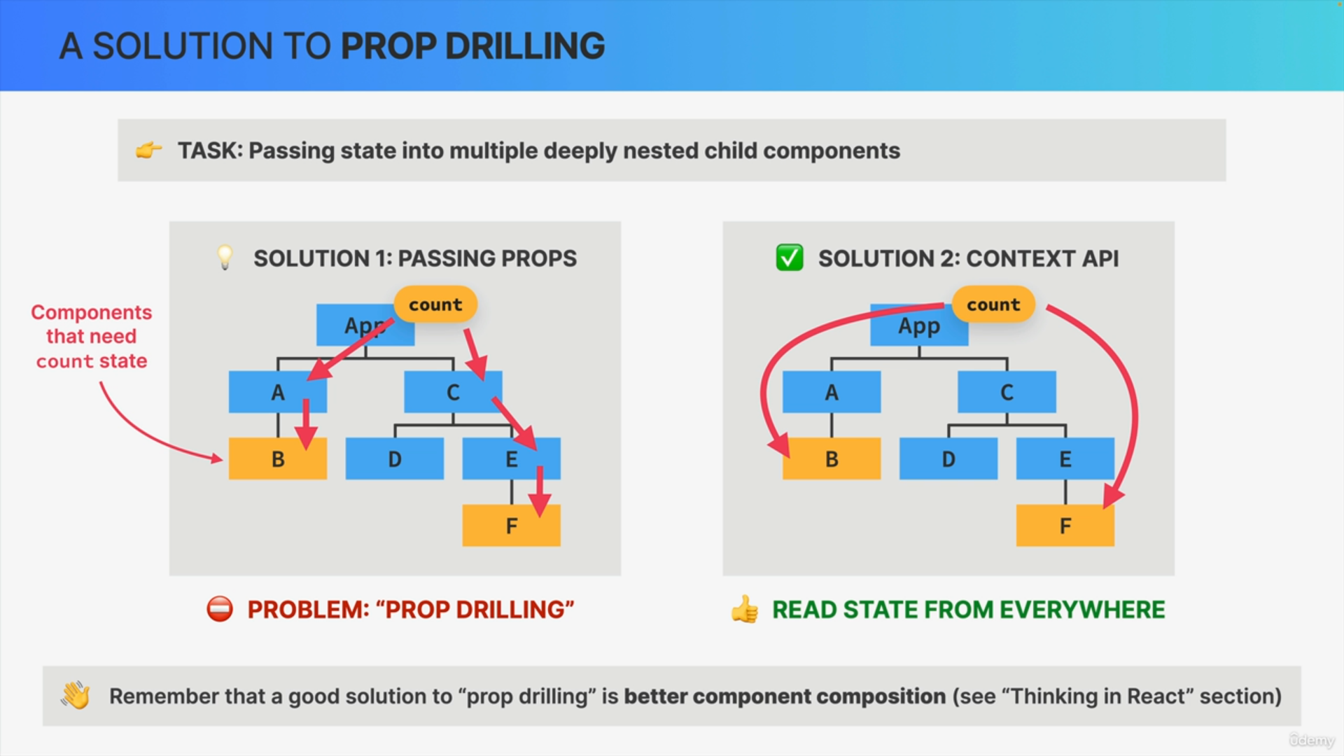

**Components**:

* Provider: A special React component that wraps the entire application (or a part of it) and provides the context's value to all child components.
* Consumer: Components that subscribe to the context and can access the provided value. Multiple consumers can exist for one provider.

**Usage**

* Define a context with createContext.
* Use Provider to wrap components that need access to the context's data.
* Use Consumer or useContext hook in child components to access the context's value.

**Reactivity**

When the context's value changes, all components subscribed to that context will re-render automatically, ensuring they reflect the updated state.

**Flexibility**

Multiple contexts can be created and nested within each other, allowing different parts of the application to manage their state independently.

Overall, the Context API simplifies state management by providing a way to share data across components without the need for prop drilling, enhancing code clarity and maintainability in large React applications.

